Chapter 20-[Countability](https://mfleck.cs.illinois.edu/building-blocks/version-1.3/countability.pdf)

Wednesday, January 11, 2023

10:20 PM

***Countability:***

Mafs facts:

Between every 2 real numbers, there is **always** at least 1 rational number.

The vast majority of real numbers are **Irrational** and the Rational numbers are only a small subset of the reals.

***Completeness of Real Numbers:***

Let’s take a step back and think about why the definition of real numbers exist in the first place (isn't rational numbers enough? why are they necessary?)

Suppose there's a sequence that is specified so that it converges to some number.

For example, consider the sequence defined by

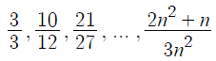

where *n* starts from 1 and goes to infinity, the sequence approaches the number 2/3. *(Calc 2 moment)*

Great!

But wait, consider the sequence defined by



These numbers are all rational, but some math proofing stuff can be done to show that the sequence gets closer and closer together, meaning that it converges to some number.

But there is just not ANY rational number that the sequence converges to!

How can a sequence converge but it does not converge to anything we know? It can't.

So the definition of real numbers were born:

They are a system of numbers that contains the rational numbers, but has the property that if there is a sequence whose elements eventually get closer and closer together, then there is some real number that the elements approach.

*(the example with variables a and b is actually the sequence that converges to the square root of 2)*

***Cardinality:***



*(This definition works for infinite sets too, which is nice)*

Using bijections, you can find that the cardinality of the natural numbers and the integers is actually the same. (you can come up with ways to map every natural number to an integer and cover all integers without duplicates)

An infinite set *A* is ***countably infinite*** if there is a bijection from *N*, the integers, (or equivalently *Z*, the integers) onto *A*.

*(basically saying that you can count all elements of this set, or label the elements using natural numbers-1,2,3,4,….)*

The term *countable* is used to cover both finite sets and sets that are countably infinite. All subsets of the integers are *countable*.

***Cantor Schroeder Bernstein Theorem:***



**If |A|≤ |B| and |B|≤|A|, then |A|=|B|.**

Therefore, if you can come up with a one-to-one functions in both directions, a bijection exists, and the 2 sets A and B have the same cardinality.

Using this theorem, we can prove many seemingly complex claims.

For example, I claim that



is countably infinite.

We can build one-to-one functions in both directions.



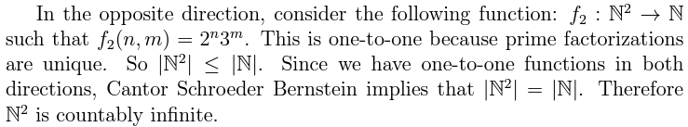

Another example:

Suppose there is a set *M* that is made of Upper Case Character strings. Like I, YOU, BOTTLE, WOTUR, and the zero length string. I claim that the set *M* is countably infinite.

Again, we can build one-to-one functions in both directions with the set of natural numbers.

We can map each natural number to a string of 'A's. (i.e. f(0) = empty string, f(1) = A, f(3) = AAA, and so on) This function relating the set of Natural numbers to *M* is one-to-one.

We can also map each string in *M* to the natural numbers by converting the strings to ASCII code (which is just a long integer). Since each string in *M* is unique, each ASCII code is also unique in the set of natural numbers, therefore one-to-one.

When is a Set ***Uncountable***?

Imagine that we have put **all** the elements of the set in a list (or more precisely, an infinite list), but then if we can still *somehow* come up with a new element that is not already in the infinite list, then the set is uncountable.

One way to show a list is uncountable list is called ***Diagonalization***.

The example below (that I may or may not have stolen from Quora and modified) should explain what diagonalization is:

Imagine you have an infinite supply of coins, and put them in an infinite row/sequence, some heads up, others tails up. Now consider all the infinitely many ways you can do that. That set of combinations is uncountable.

To prove it, imagine making a list of **all** the combinations. It would look like an infinite array of coin rows/sequences (imagine an infinite 2D array of individual coins), each row/sequence consisting of a unique infinite combination.

Now take the first coin from the first row, the second from the second row and so on. This makes a new sequence of coins. Flip them all over and put them aside as a new row/sequence. We now have a sequence whose first coin is different from the first coin in the first row, whose second coin is different from the second coin in the second row and so on. Therefore this sequence can't be the same as any sequence in the list, which means it isn't in the list. That contradicts our original assertion that **all** the sequences were in the list.

The same thing can be done to show that the Powerset the natural numbers, or



, is uncountable.

The set of functions, even from the integers to the integers, is **uncountable**.

*(there are an uncountable number of functions)*

But also note that there are a ***countable*** number of formulas, or computer programs, since they are all written using characters, or ASCII strings, and therefore countable.

This means that there are functions which **cannot** be computed by **any** program!

Specifically, it can be shown that it is not possible to build a program that analyzes the code of other programs and decides whether they eventually halt or run forever. This is called the ***Halting Problem*** and its proof uses a variation of diagonalization.

This makes sense, since there are 3 possible kinds of program behavior:

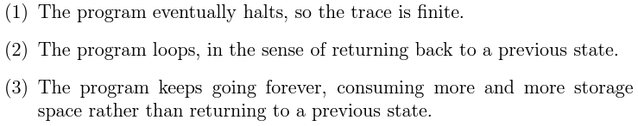

*(The Halting Problem exists because of the existence of the 3rd kind of behavior, we cannot tell the difference between the 2nd and 3rd)*